

**The Arab American University**

Faculty of Engineering and Information Technology

Computer Systems Engineering Department

**Senior Project I**

**Mobile Application for Renting stuffs**

***Prepared by:***

**Muna Yassin 201612097**

**Jana Hamarsheh 201710451**

**Razan Thaher 201611769**

***Supervisor: Mahmoud Saleh Obaid.***

**Submitted in Partial Fulfilment of the Requirement for the Degree of Bachelor of Computer Systems Engineering**

**February 2021s © Arab American University – Palestine**

**Jenin-2021.**

**All Rights Reserved.**

**We hereby approve the report entitled:**

**Project Title: Mobile Application for Renting stuffs**

***Prepared by:***

**Muna Yassin 201612097**

**Jana Hamarsheh 201710451**

**Razan Thaher 201611769**

**Advisors: ………………………….**

**Signature: __________**

**Date: _____________**

**Abstract**

**Table of Contents**

**List of Tables**

**List of Figures**

**Chapter One**

**Introduction**

# **1.1 Background and Motivation**

Money is the thing we all care about, hard to get, easy to go. Because we care about our and your money and we don’t want to waste it on things that is so important but we only use it once. We found the solution for this problem that we all face.

One day one of our team was traveling to study abroad, living in students’ dormitory, she wanted to use iron to do her clothes, but unfortunately they didn’t have one in the dorm so she had to buy a new one to do her clothes, it was the same problem for kitchen stuffs she had to buy new stuffs. After finishing her study abroad, she couldn’t take the stuffs for her country in the plane, she had to left them there losing her stuffs and money as well!

Also when you travel you need some stuffs for one use but you don’t want to buy because you’re going to throw them away after using it.

If you even search for renting application, you can find many for houses and cars but little bit for renting stuffs.

Even if you already bought the stuffs but never used you can rent them out earning money than putting them in your store.

From here We found our idea “Why to buy if you can rent?”

# **1.2 Aims and Objectives**

We are proposing a smart application that mainly aims to facilitate people’s lives.it achieves the following objectives:

* Facilitate the operation of renting for anything.
* Take advantage of time by saving the time needed to go shopping or looking for the required stuff.
* Help people to save money instead of spending extra money to buy unnecessary stuffs.
* Increase the people’s awareness about the idea of sharing stuffs and non-monopoly.
* Be the main link between two separate people: the renter and the renter out.
* Help people to exploit their extra and unused stuffs.
* Organize a social fellowship to connect a renter and a renter out through the application.

# **1.3 Problem Statement**

Most of us buy so many stuffs, expensive or cheap, that we rarely use, in the same time they are necessary to own even for rare use. Many other people would like to own such stuffs for a short while and are not able to afford them, they would like to be able to use them only when they need them. Also, people who travel for another city or country and students in accommodations always need to use some stuffs for some time and return them back to let other people, or other students, to use them.

If people were able to rent anything they need for a while and return it back, life would be really easier and better. The idea of our project came from here.

As an Arab members’ society, we lack for the awareness of sharing our own different stuffs. So, we are introducing our application to enhance the idea of helping other people and relieve the financial stress on each other.

# **1.4 Contributions**

………………………………………………………………………………………

**Chapter Two**

**Literature Review**

# **2.1 Overview**

As we all know that nothing starts from Zero, so our project also the same in this part we will present several existing systems that are similar to our project, but not completely the same. Most of These applications made to do one or two function at all, so our application will take the advantage and include them all in one super application.

# **2.2 Existing Systems**

As we mentioned before that most of the applications focus on renting houses and cars, it is rarely to find applications for renting stuffs, but we found some of existing renting stuffs applications that presenting different services, functions and locations.

**2.3.1 Idle**

Renting application that allows you to rent stuffs from people around you, it has a delivery feature that allows you to select their drivers or stuffs owners or you can take it by yourself with guarantee to cancel your order anytime because it has no electronic payment way like credit card or PayPal.

Also it has a feature that allows you to put your stuffs inside lists.

It gives you the calendar as a feature to let you know when are you going to rent the stuff.

Finally, it has Earning feature that inform you how much money you earned from the stuffs you rented out.

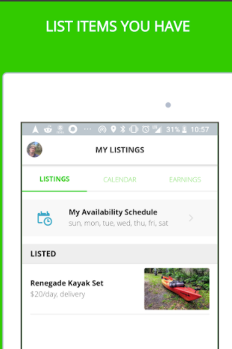

**2.3.2 Rent Your Stuff**

This application allows you to rent out your stuffs and earn money and sorting them in categories like electronics, books, home and gardens.

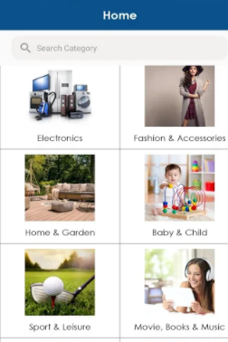

**2.3.3 All4Rentz**

This is a new application started from lockdown it allows you to rent anything from a-z.

In this application you can specify what the rental plan you want “per month, per year, per day... etc.”

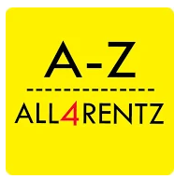 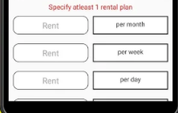

**2.3.4 Airbnb**

We all tried or at least know this This amazing application for renting houses, especially if you’re travelling in groups. this application gave us the idea to build our project, it has so many different amazing features like evaluation, rating, comments this features gives you others opinion about the houses they rented, we are going to use these features but for the stuffs.

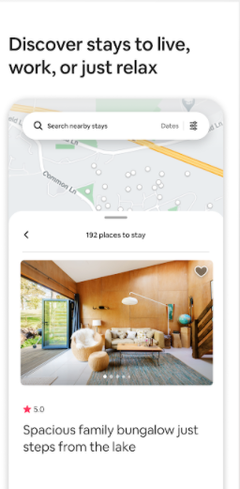

**2.3 Summary**

All the mentioned systems before give separated functions and different features, it is not available in our country. Our application will collect all the functions and features to give a new intelligent system in our county. Our system will give you the closest stuff’s location to rent. Also notify the renter of the time he should rent and return it back, it will improve the culture of collaboration between citizens. Our project will not be for a specific group of community, it will be used from all people in the county so it will be easy to use, simple layout, and smart enough to give a specific search results.

**Chapter Three**

**System Design and Solution**

# **3.1 Introduction**

In this chapter, we are introducing the main software components we are using in our systems. We are explaining the algorithms used to implement the application. Also, we are presenting the flowcharts and diagrams followed to build the software.

# **3.2 Hardware**

We are not using any hardware components in our application, it’s all a software design.

**3.3 System Architecture and Algorithms**

MVC Pattern or Model-View-Controller Pattern is suitable for implementing the application since it separates the application design into three main parts:

The first is Model: it presents the state of the application, the business logic of it, and operation done by the application.

The second is View: responsible for the user interface and its components.

The third is Controller: it’s responsible for user interaction handling of data displayed by View. It connects Model and View together by deciding which Model is more suitable and how data will be displayed by View.

# **3.4 System Design**

The main purpose of the system is to give a chance for people to share their stuff with other people who need them for a short time. Our application is using some intelligent algorithms, like k nearest neighbor searching algorithm to search the top matching items, and another sorting algorithm to show up all sorted items depending on the chosen sorting type. A clustering algorithm is used to display the most demand items to users.

In figure 1, we introduce the main algorithm flowchart for the system. At first, the user can create account, after logging in as a renter, the user can switch his status to become a renter out so that he can add stuffs to be rented by normal users. Added stuffs should have a name, category, location, price, description and interest. If the user continues as renter, he can search any stuff in the “Search” box, and all related items will be shown. The user can choose a sorting type to view items as he’s interested in. he can sort items depending on closest location, lowest price and highest price. If the user chooses an available item, he can add it to his own cart and finish the renting operation after paying its rental price.

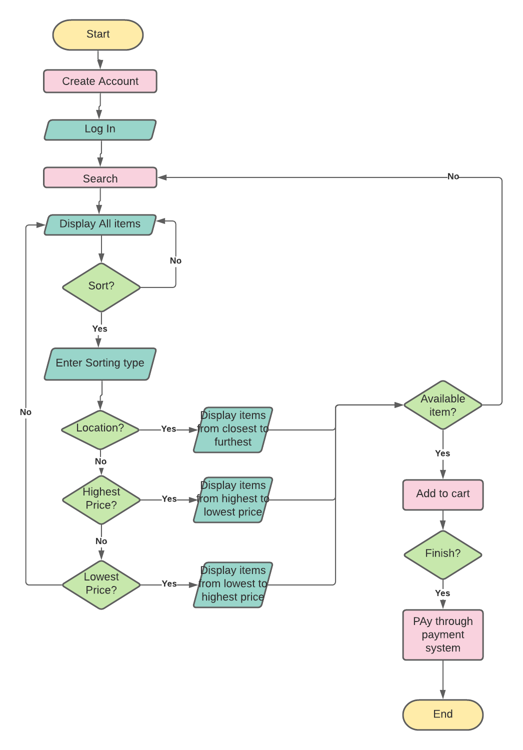

Figure 1

# **3.3.1.1 Search Algorithm**

The job of search algorithm is to find the most relative item to the searched one among all of the inserted items in the database. A user can type a word in the search box to search all relevant stuffs to this word. All these stuffs will be displayed to the user to choose which of them to rent.

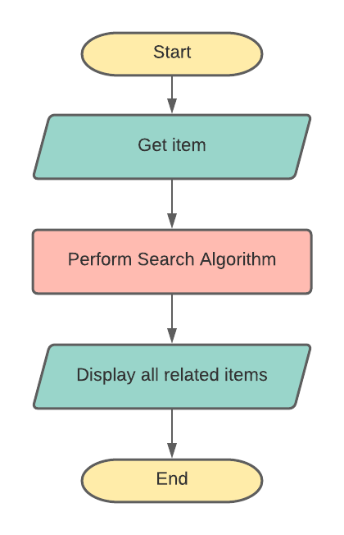

Figure

# 

# **3.3.1.2 Sorting Algorithm**

The job of the sorting algorithm is to rearrange the given unordered collection of items as inputs and return sorted items in a data structure. The comparison operator, or the sorting type, determines the operation to order these data inputs.

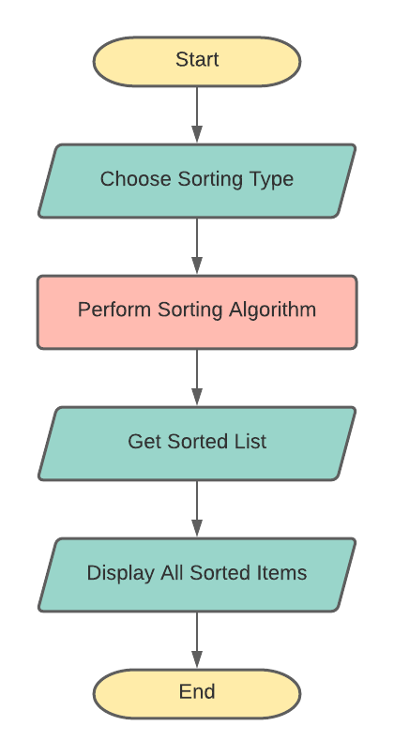

Figure

**Chapter Four**

**Conclusion and Future Work**

# 

# **4.1 Conclusion**

We Build a mobile application that will improve our life and make it easy to life,

It has many advantages:

* Saves money and time.
* Make strong relationship between citizens.
* No matter from where or when are you renting.
* Make money from unused stuffs.

# **4.2 Future Work**

**Acknowledgments**

**References**

1. https://www.mathscareers.org.uk/search-algorithms-help-online-customers/
2. <https://dotnet.microsoft.com/apps/aspnet/mvc>
3. <https://docs.microsoft.com/en-us/aspnet/core/mvc/overview?view=aspnetcore-5.0>
4. <https://play.google.com/store/apps/details?id=com.kunasainath.all4rentz>
5. <https://play.google.com/store/apps/details?id=com.rentyourstuffs>
6. <https://www.getidle.com/#/>
7. <https://play.google.com/store/apps/details?id=com.airbnb.android>